Safir
Xi tkj
DOKUMENTASI DNS

BIND or BIND 9 is an open source implementation of DNS, available for almost all Linux distributions. BIND stands Berkeley Internet Name Domain & it allows us to publish DNS information on internet as well as allows us to resolve DNS queries for the users. BIND is by far the most used DNS software on Internet.
DNS or Domain Name System, as we know is an internet service that is used to translate the user friendly domain into computer friendly IP addresses. Not only can we translate domain names to IP addresses, we can also perform reverse translation i.e. from IP addresses to domain name translations. In this post, we are going to learn to setup a private DNS server by implementing BIND 9 on Ubuntu 24.04 and Ubuntu 22.04. Steps are identical for these two Ubuntu versions.
https://www.linuxtechi.com/install-configure-bind-9-dns-server-ubuntu-debian/

.1 install
sudo apt install -y bind9 bind9utils bind9-doc dnsutils

.2 setup bind (dns server)
“/etc/bind/named.conf.options“, from this file we can set the followings parameters:

Allow Query to your dns from your private network (As the name suggests only the systems from your private network can query dns sever for name to ip translation and vice-versa)
Allow recursive query
Specify the DNS port ( 53)
Forwarders (DNS query will be forwarded to the forwarders when your local DNS server is unable to resolve query)
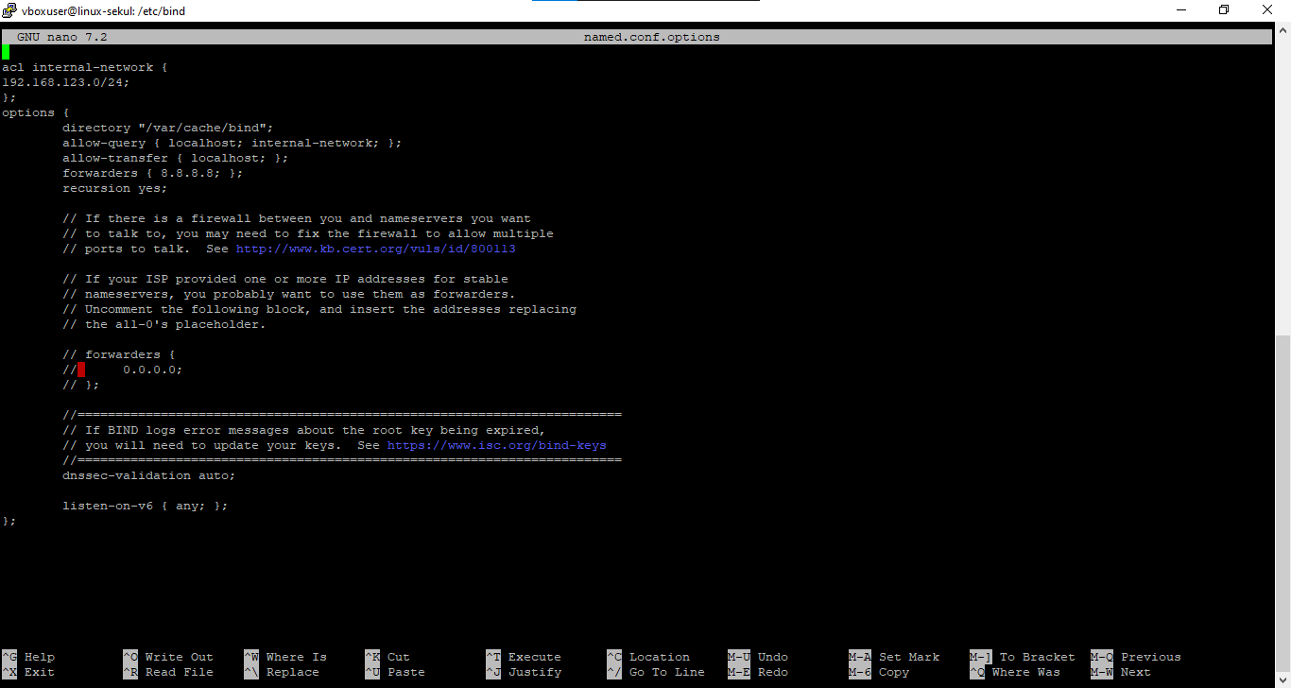

Next Important Configuration file is “/etc/bind/named.conf.local“, in this file we will define the zone files for our domain, edit the file add the following entries:

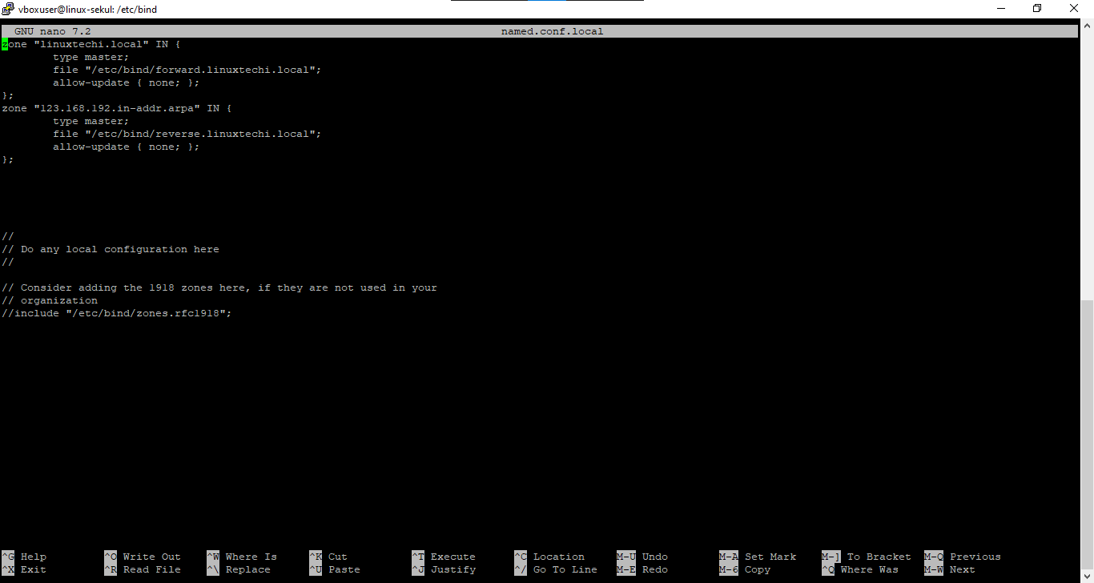

Save the file & exit. Here we have mentioned locations for our forward lookup zone file & reverse lookup zone files. Next we will create the mentioned forward & reverse zone files.

Firstly create the forward lookup zone file, Sample zone files (db.local) are already there in ‘/etc/bind’ folder, we can use and copy sample zone file,

cd /etc/bind
sudo cp db.local forward.linuxtechi.local
sudo vi forward.linuxtechi.local
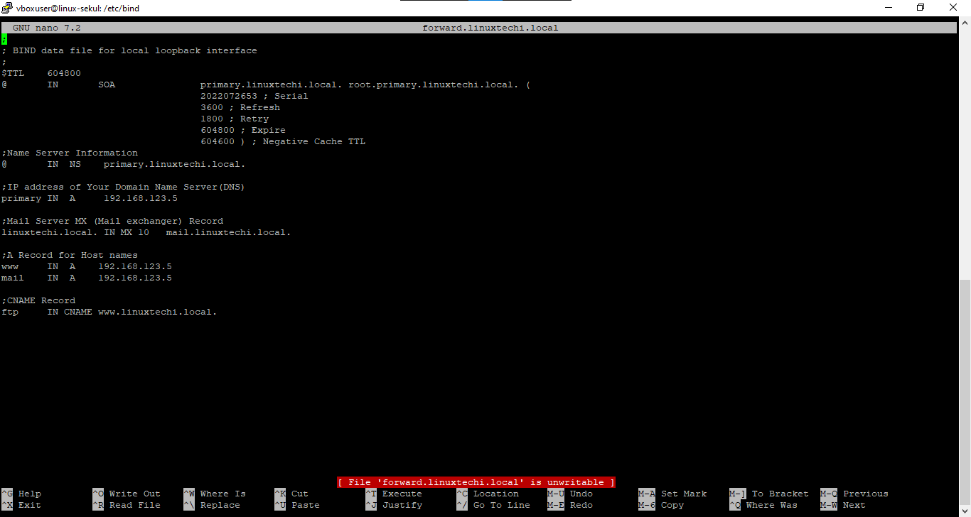

Here, we have added information regarding our DNS server & have also added A records for couple of servers, also added record for a mail server & CNAME record for ftp server. Make sure you edit this file to suit your network.

Next we will create a reverse lookup zone file at the same location,sample reverse lookup zone file is present at ‘/etc/bind‘ folder.

sudo cp db.127 reverse.linuxtechi.local
sudo nano /etc/bind/reverse.linuxtechi.local
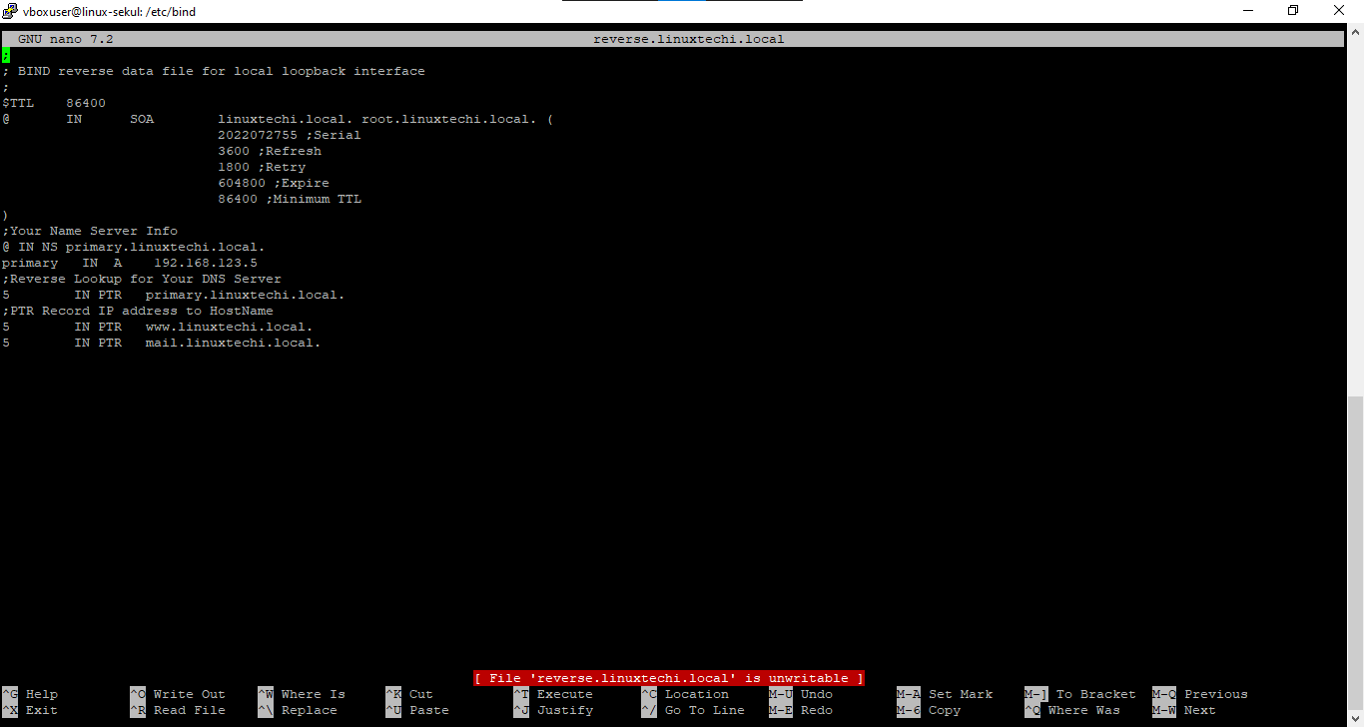

Update the following parameter in ‘/etc/default/named ‘ file, so that dns service starts listening on IPv4
OPTIONS="-u bind -4"

Now all we have to do is to start and enable the BIND service to implement the changes made,
sudo systemctl start named
sudo systemctl enable named

View the bind service status, run
sudo systemctl status named

In case OS firewall is running on your bind server then execute the below command to allow 53 port
sudo ufw allow 53

Cek syntax error
If you want to cross verify the syntax of your bind 9 configuration file (named.conf.local). Use the command “named-checkconf“, example is shown below:
sudo named-checkconf /etc/bind/named.conf.local
If there is no syntax error in your bind configuration file, then it should return to shell without showing any errors.

To cross verify the syntax your forward and reverse lookup zone files , use the command “named-checkzone”, example is shown below:
sudo named-checkzone linuxtechi.local /etc/bind/forward.linuxtechi.local
zone linuxtechi.local/IN: loaded serial 2022072651
OK
$
sudo named-checkzone linuxtechi.local /etc/bind/reverse.linuxtechi.local
zone linuxtechi.local/IN: loaded serial 2022072752
OK
$

Coba dns
nslookup primary.linuxtechi.local (di laptop )

